GitHub Link: <https://github.com/Unserved-sleep/Information-visualization-/tree/main/ParaView%20Assignment>

1.  Import the provided dataset, create a 3D rendering with the "Outline" filter, adjust the view, and submit a screenshot.

The outline view displays a bounding box that surrounds your entire dataset, providing a clear reference for the spatial extent of the data. It doesn’t show internal details but rather helps you understand the overall size and orientation of the data within the 3D space.

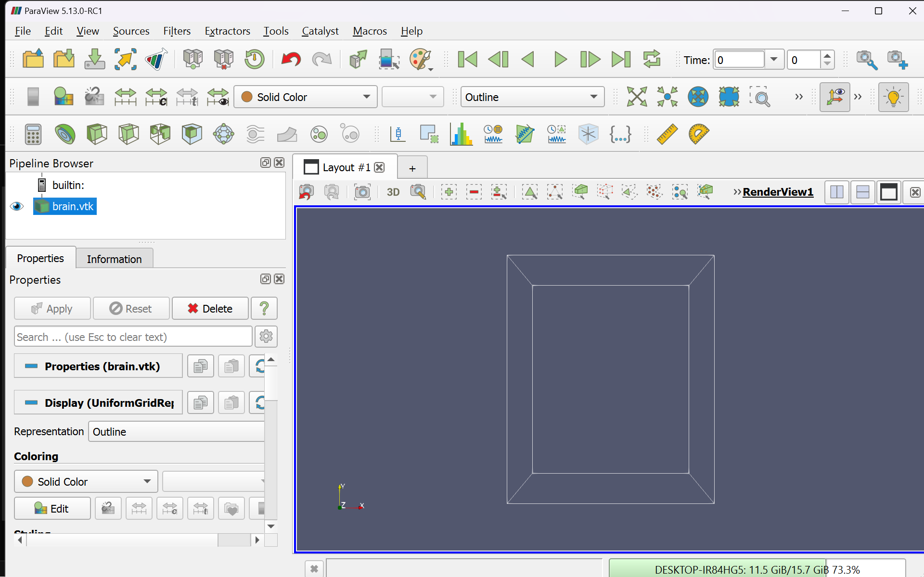

**Isosurface**

An isosurface represents a 3D contour that connects points of equal value within a volume dataset. It's essentially a surface that forms at a constant scalar value (e.g., temperature, pressure, or intensity) within the data.

**Clip filter**

The clip tool allows you to slice through a 3D dataset along a defined plane, effectively "cutting" the data to reveal internal features. The parts of the dataset on one side of the plane are hidden, making it easier to focus on specific areas.

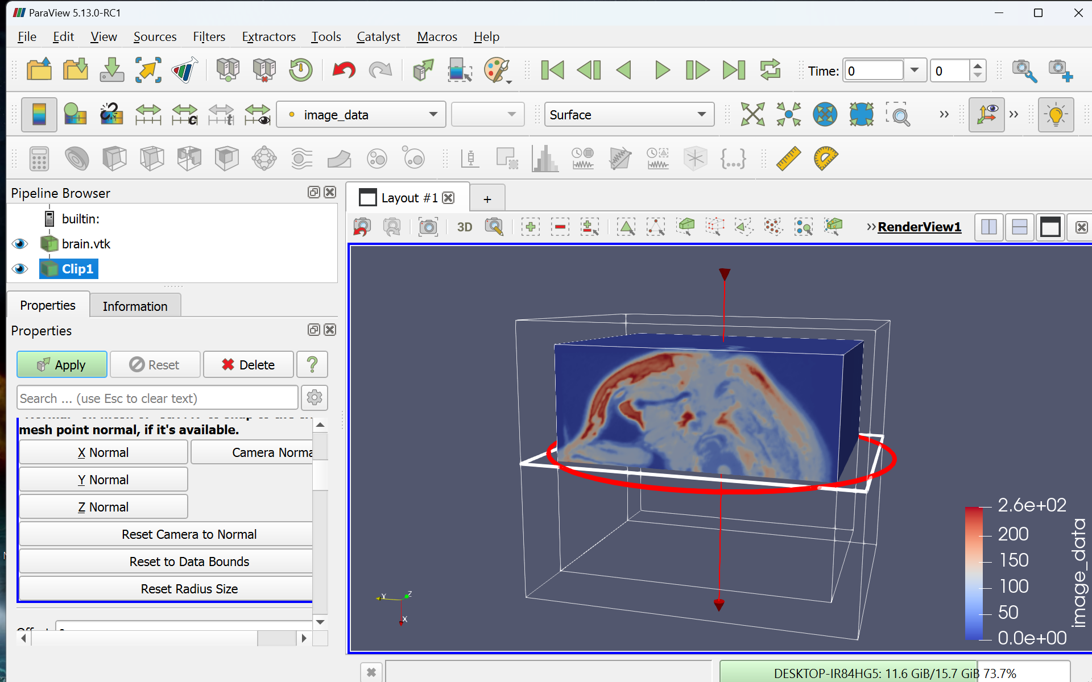

**Slice**

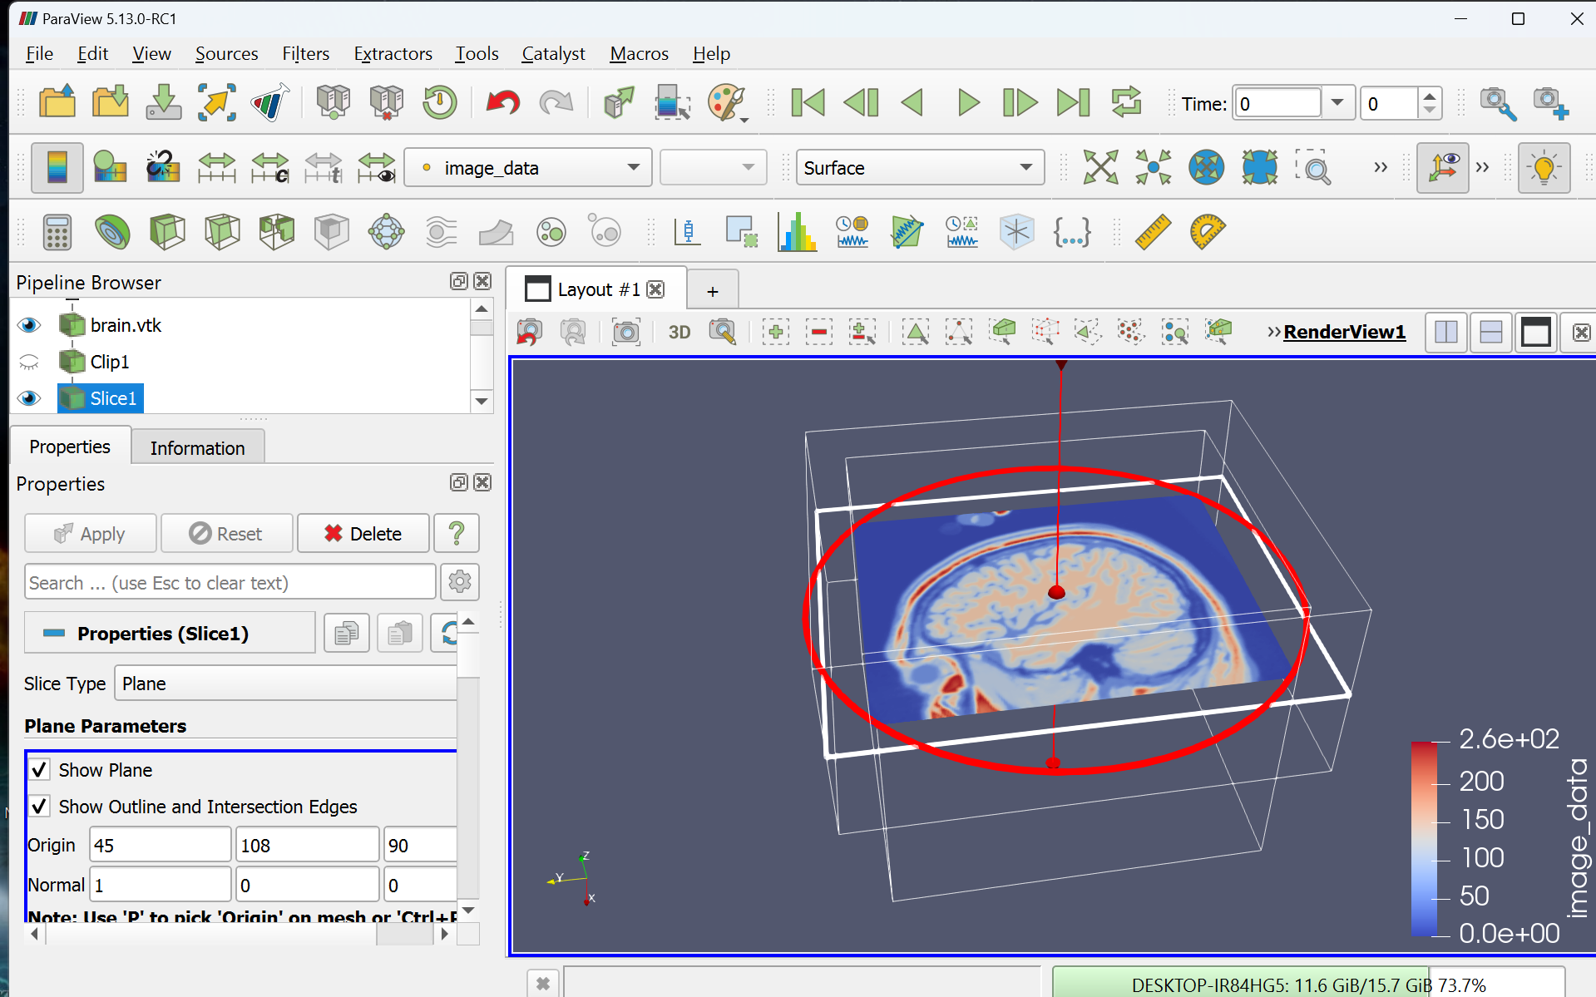A slice creates a 2D cross-section of a 3D dataset at a specific position along a chosen plane (e.g., XY, XZ, or YZ plane). This cross-section shows the values of the dataset along that plane, effectively converting a 3D view into a 2D image.

**Threshold**

The threshold tool allows you to filter and display only the parts of a dataset that fall within a specified range of values. Data points outside this range are hidden, leaving only the areas of interest visible.

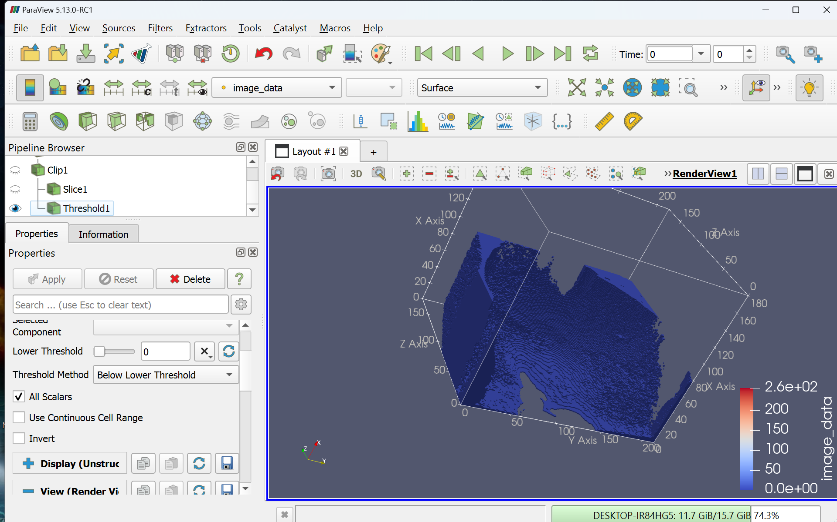 **Below**

**Between**

